**Design Pattern and SOLID principle**

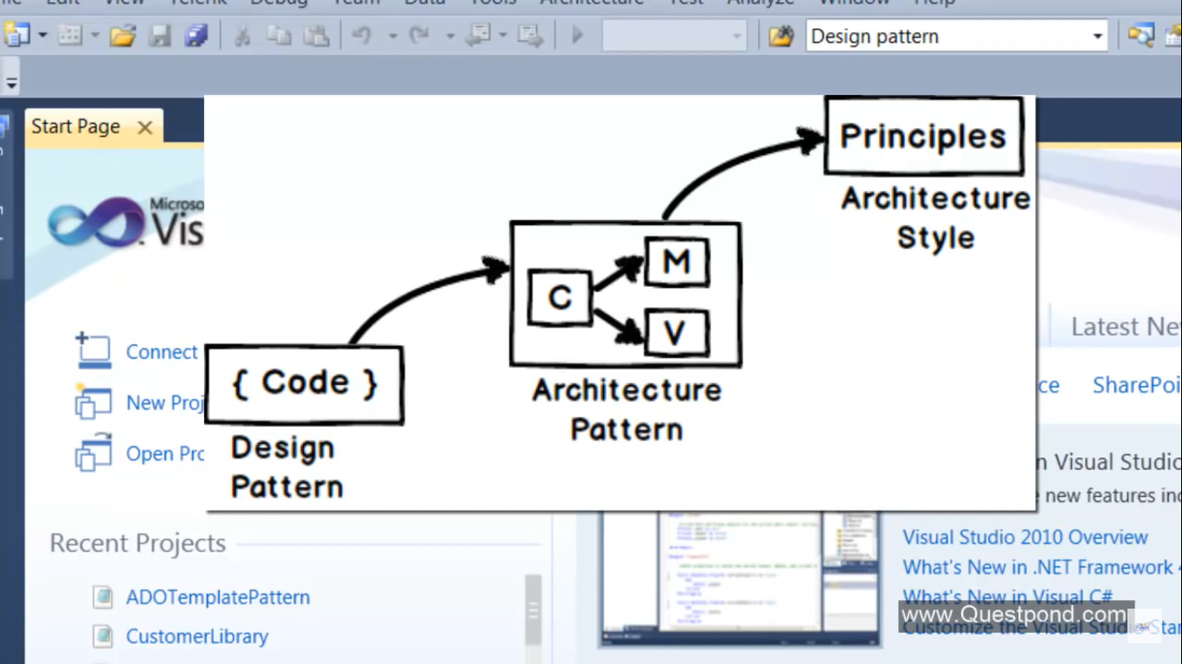

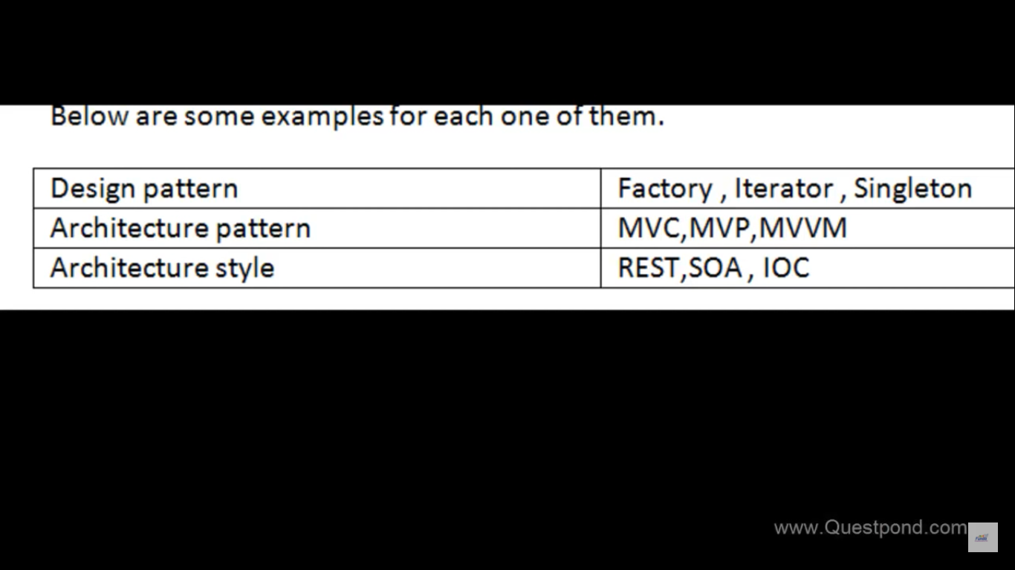

Design pattern are time tested practices for OOP problems